Game Tracker External Documentation

Nisarg Patel (200292593)

Jinal Patel (200299533)

Enterprise Computing

Tom Tsiliopoulos

Wednesday, June 15, 2016

**Table of contents**

Logo Image 3

Detailed description 4

Version History 4

Wireframes Section 5

Home Page 5

About Page 6

Game Page 7

Contact Page 8

Login Page 9

Screen Capture Section 10-12

Logo:-  
  
This is Our Web Site Logo. We haven’t added on site but it will be on header.



Detailed description:-

Game Tracker

We are providing platform where user can login and we can keep weekly records and statistics on game. Out main page will provide weekly records on game and each game will track two teams’ records with score and results of the game. In game we will show spectators on the game which is excited part.

When user first sign up for a Game they are going to provide a number of questions about them like Name, Username, Password, Email Address. It can be a little time consuming, but our recommendation is to sign up for all secure game pages.

Version History:-

Git hub Link: - https://github.com/Nisarg1503/GameTracker

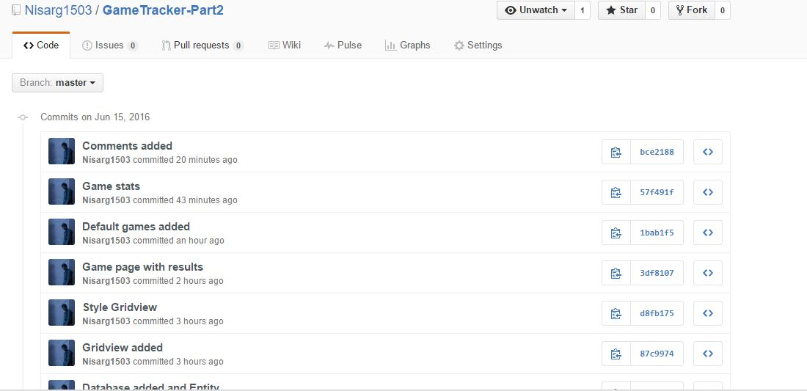

Wireframes Section:-

Home Page:

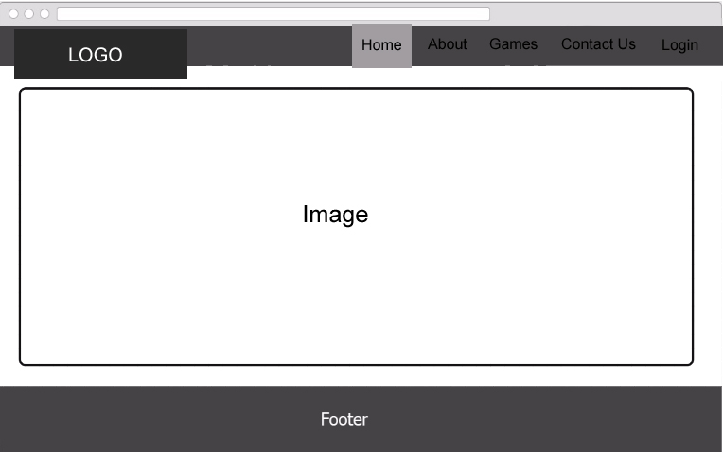

About Page:-

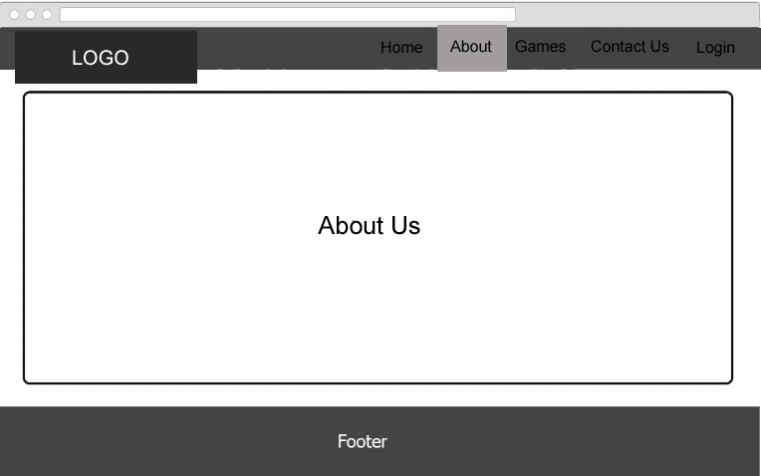

Game Page:-

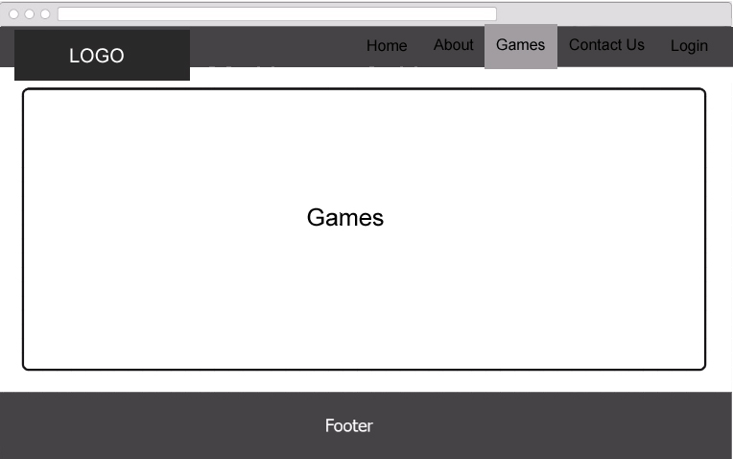

Contact Page:-

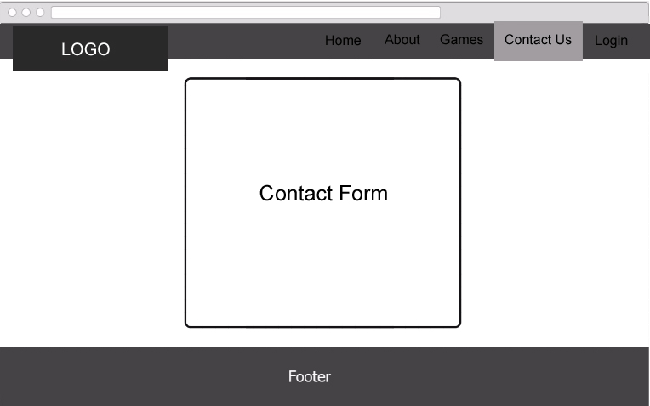

Login Page:-

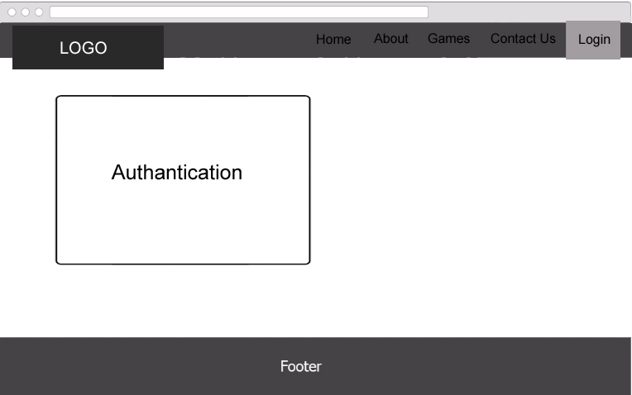

Screen Capture Section:-

This is the Screen shots of our Home, About, Game, Contact, Login , Register Page.

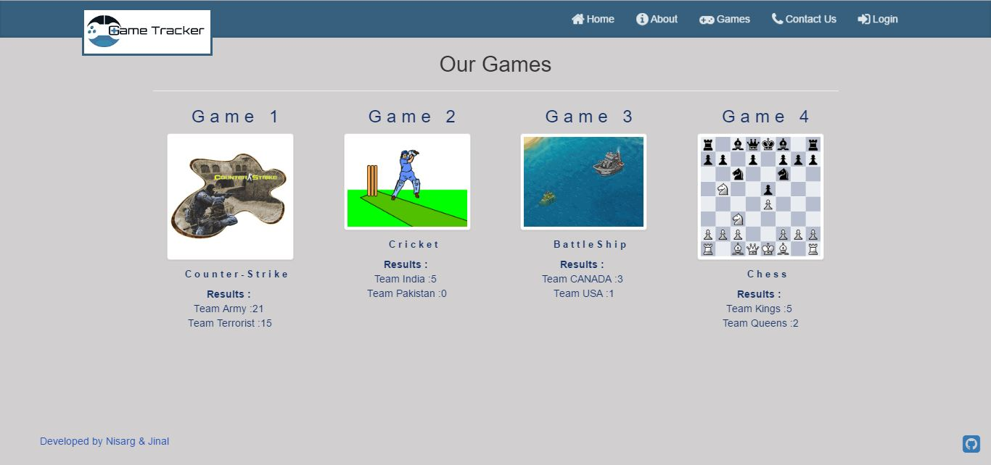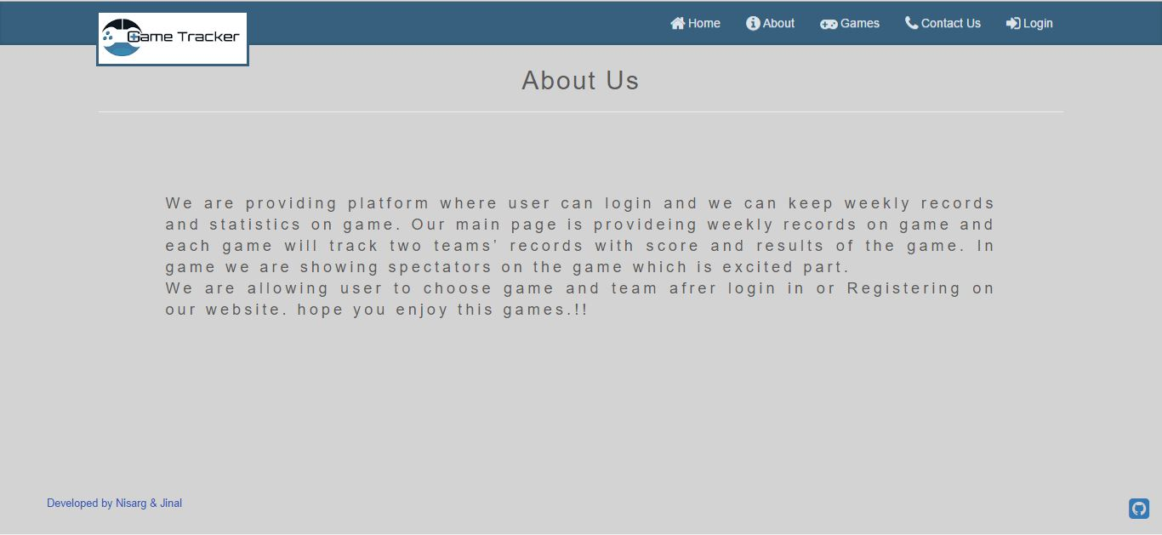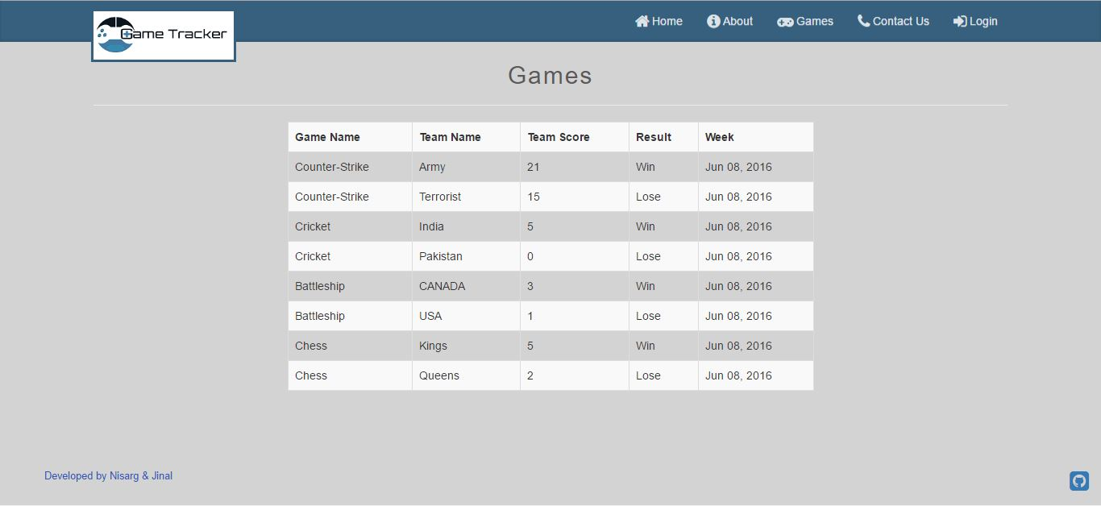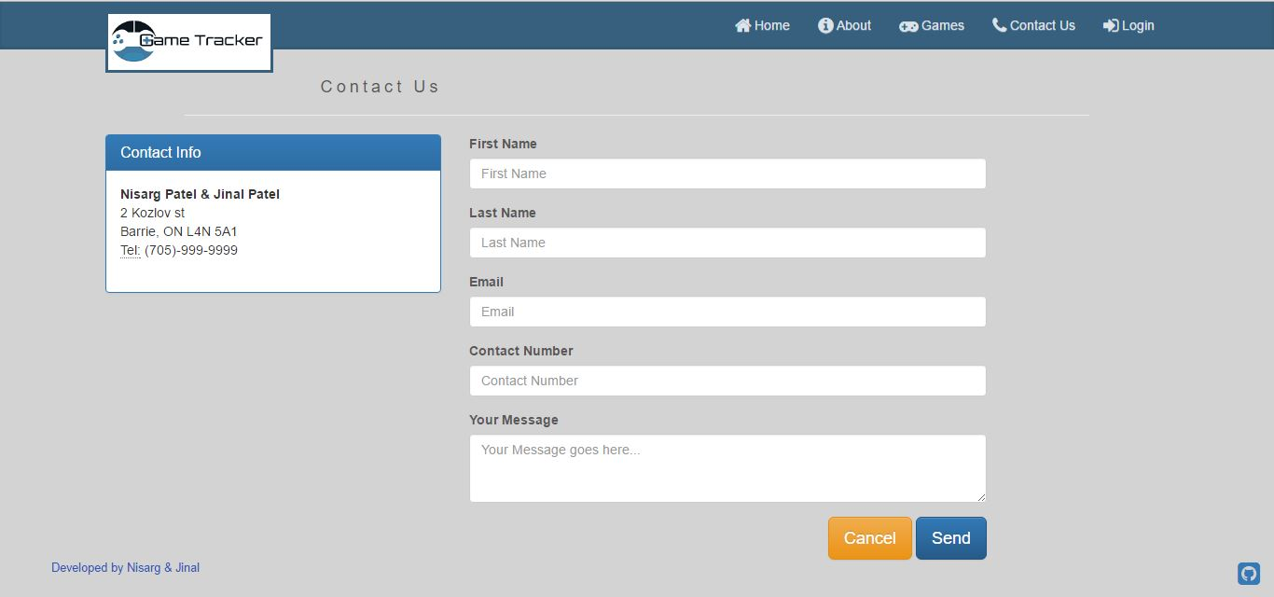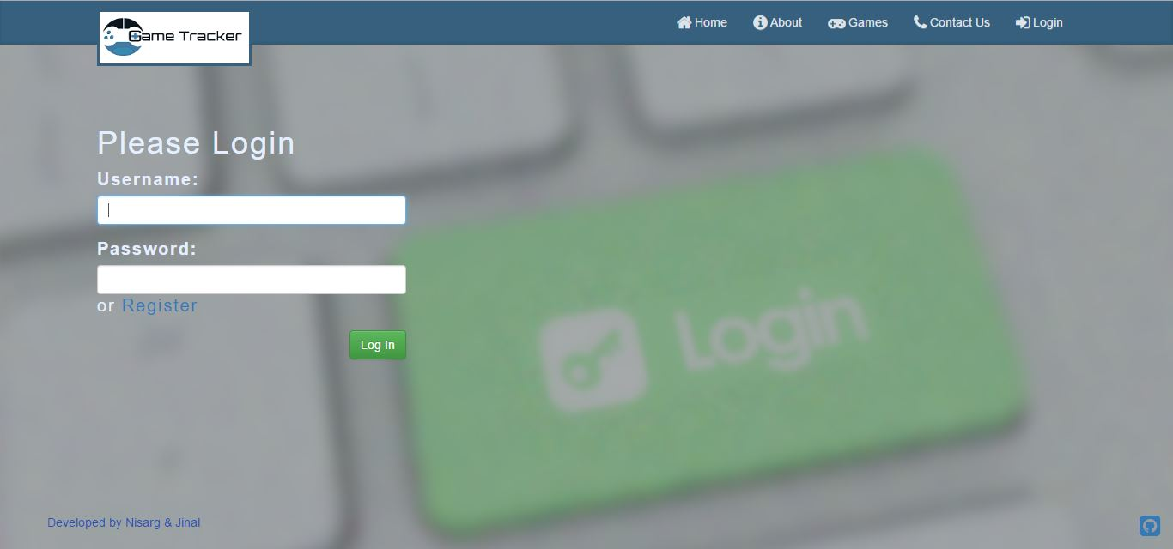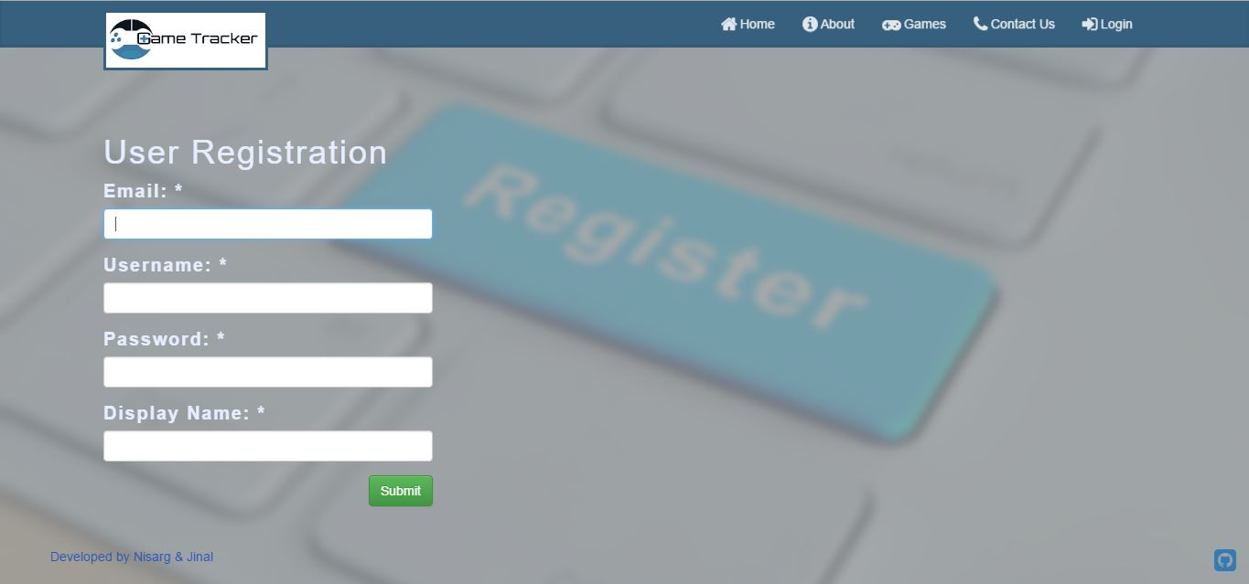

Thank you!